

|  |  |
| --- | --- |
| **CHATTOOGA INDIAN WRESTLING** | |
| **AA STATE TRADITIONAL CHAMPIONS** | **2020** |
| **AA STATE DUAL CHAMPIONS** | **2020** |
| **AREA TRADITIONAL CHAMPIONS** | **1997, 1998, 2018, 2020** |
| **AREA DUAL CHAMPIONS** | **2020** |
| **AA STATE DUAL RUNNER-UP** | **2002** |
| **AREA TRADITIONAL RUNNER-UP** | **1996, 1999, 2002, 2019** |

|  |  |
| --- | --- |
| **CHATTOOGA INDIAN TAKEDOWN CLUB** | |
| **106** | **CHATTOOGA TRUCK & TIRE** |
| **113** | **ADVOCARE** |
| **120** | **ZAXBY’S** |
| **126** | **HARVEY’S SOUTHEND AUTO** |
| **132** | **OAK HILL FARMS** |
| **138** | **BURDICK ENTERPRISES** |
| **145** | **CRUSHED TOMATO** |
| **152** | **MCDONALDS** |
| **160** | **ADAMSBURGER GRILL** |
| **170** | **AMERICAN ROOFING COMPANY** |
| **182** | **PEPPERS PRODUCTIONS** |
| **195** | **T & L ELECTRIC**  **TRY CON TUFTERS** |
| **220** | **GILLILAND PROPERTIES**  **PAUL MEREDITH** |
| **285** | **SWEET P’S**  **RUBY SLIPPERS** |

|  |  |  |  |
| --- | --- | --- | --- |
| **STATE TOURNAMENT TOP 10 FINISHES** | | **ACADEMIC ALL-AMERICANS** | |
| **1996** | **9TH** | **1998** | **KEVIN ESPY** |
| **1997** | **3RD** | **1999** | **CHRIS BUTLER** |
| **1998** | **7TH** | **2008** | **ELVINO FELIPE** |
| **1999** | **5TH** | **2008** | **JOHNNY REECE** |
| **2002** | **4TH** | **2018** | **GRIFFIN JARRETT** |
| **2003** | **5TH** | **2018** | **JAKOBY COTTRELL** |
| **2017** | **6TH** | **2019** | **GRIFFIN JARRETT** |
| **2018** | **7TH** | **2020** | **GRIFFIN JARRETT** |
| **2019** | **3RD** |  |  |
| **2020** | **1ST** |  |  |

|  |  |
| --- | --- |
| **TEAM RECORDS** | |
| **HIGHEST STATE FINISH (TRADITIONAL)** | **1ST-2020** |
| **HIGHEST STATE FINISH (DUAL)** | **1ST-2020** |
| **HIGHEST AREA FINISH (TRADITIONAL)** | **1ST-1997, 1998, 2018, 2020** |
| **HIGHEST AREA FINISH (DUAL)** | **1ST-2020** |
| **MOST WINS IN A SEASON** | **31-2018** |
| **MOST PINS IN A SEASON** | **330-2020** |
| **MOST TOURNAMENT TITLES IN A SEASON** | **6-2020** |
| **MOST STATE QUALIFIERS IN A SEASON** | **12-2002** |
| **MOST STATE PLACERS IN A SEASON** | **9-2020** |
| **MOST STATE FINALISTS IN A SEASON** | **7-2020** |
| **MOST STATE CHAMPIONS IN A SEASON** | **5-2020** |
| **MOST AREA CHAMPIONS IN A SEASON** | **7-2020** |
| **BEST SEASON WINNING PERCENTAGE** | **.954 (21-1)-2020** |

|  |  |
| --- | --- |
| **INDIVIDUAL RECORDS** | |
| **MOST SEASON WINS** | **GRIFFIN JARRETT-2017 (69)** |
| **MOST CAREER WINS** | **GRIFFIN JARRETT-2017-2020 (247)** |
| **MOST SEASON PINS** | **ALEX MEARS-2017 (46)** |
| **MOST CAREER PINS** | **ALEX MEARS-2017-2020 (162)** |
| **MOST SEASON TOURNAMENT TITLES** | **DUSTY BROWN-1998 (7)**  **BRANDON SIFFLES-2011 (7)** |
| **MOST CAREER TOURNAMENT TITLES** | **GRIFFIN JARRETT-2017-2020 (21)** |
| **BEST SEASON WINNING PERCENTAGE** | **J.J. BLANKENSHIP-2013 (1.000/53-0)**  **TY VEATCH-2021 (1.000/20-0)** |
| **BEST CAREER WINNING PERCENTAGE** | **GRIFFIN JARRETT-2017-2020 (.957/247-11)** |
| **FASTEST PIN** | **KEVIN ESPY-1998 (7 SECONDS)**  **DARIUS LAWRENCE-2016 (7 SECONDS)** |

|  |  |  |  |
| --- | --- | --- | --- |
| **3X STATE PLACERS** | | **4X STATE PLACERS** | |
| **ANDY STIVERS** | **1997-1999** | **CHRIS THOMPSON** | **1991-9994** |
| **CHRIS BUTLER** | **1997-1998** | **DUSTY BROWN** | **1995-1998** |
| **BRANDON CARLTON** | **2001-2003** | **GRIFFIN JARRETT** | **2017-2020** |
| **SAM ALLMOND** | **2001, 2003, 2004** | **ALEX MEARS** | **2017-2020** |
| **JOSE MEDRANO** | **2002-2004** |  |  |
| **BRANDON SIFFLES** | **2009, 2011, 2012** |  |  |
| **J.J. BLANKENSHIP** | **2010, 2012, 2013** |  |  |
| **JAKOBY COTTRELL** | **2018-2020** |  |  |
| **LUIS MEDINA** | **2018-2020** |  |  |
| **TY VEATCH** | **2019-2021** |  |  |

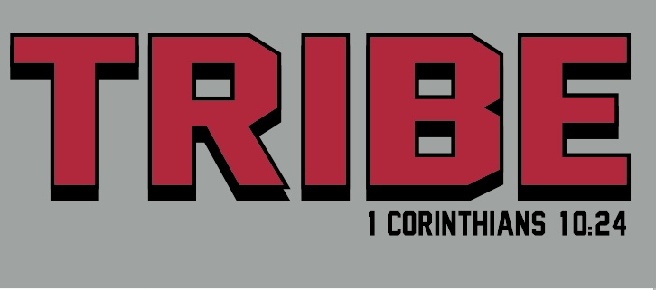

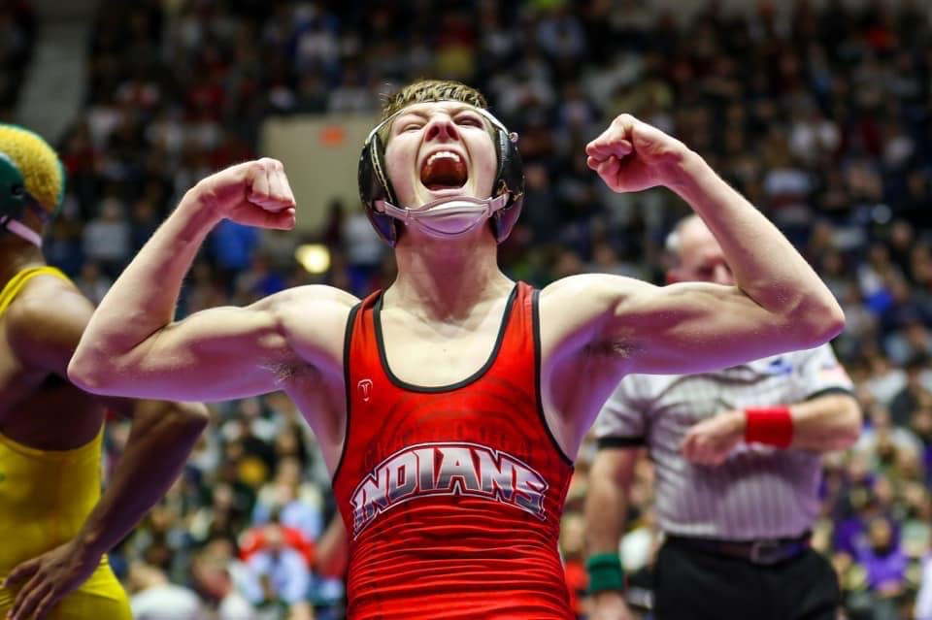

|  |  |  |
| --- | --- | --- |
| **INDIVIDUAL STATE CHAMPIONS** | | |
| **JOHN LAWRENCE** | **135** | **1993** |
| **TOMMY DOVER** | **189** | **1996** |
| **DUSTY BROWN** | **125** | **1998** |
| **CHRIS BUTLER** | **152** | **1999** |
| **ANDY STIVERS** | **215** | **1999** |
| **ALAN HAWKINS** | **160** | **2002** |
| **BRANDON CARLTON** | **113** | **2003** |
| **BILLY HENDERSON** | **189** | **2003** |
| **ELVINO FELIPE** | **119** | **2008** |
| **BRANDON SIFFLES** | **119** | **2009** |
| **BRANDON SIFFLES** | **140** | **2011** |
| **BRANDON SIFFLES** | **152** | **2012** |
| **J.J. BLANKENSHIP** | **126** | **2013** |
| **GRIFFIN JARRETT** | **106** | **2017** |
| **GRIFFIN JARRETT** | **106** | **2018** |
| **GRIFFIN JARRETT** | **106** | **2019** |
| **ALEX MEARS** | **220** | **2019** |
| **LUIS MEDINA** | **285** | **2019** |
| **GRIFFIN JARRETT** | **113** | **2020** |
| **WES CONLEY** | **120** | **2020** |
| **MASON STERNER** | **145** | **2020** |
| **ALEX MEARS** | **220** | **2020** |
| **LUIS MEDINA** | **285** | **2020** |
| **TY VEATCH** | **220** | **2021** |
| **SECTIONAL CHAMPIONS** | | |
| **BRANDON SIFFLES** | **119** | **2009** |
| **CODY SIFFLES** | **135** | **2009** |
| **BRANDON SIFFLES** | **140** | **2011** |
| **BRANDON SIFFLES** | **152** | **2012** |
| **BRANDON BROWN** | **120** | **2013** |
| **J.J. BLANKENSHIP** | **126** | **2013** |
| **GRIFFIN JARRETT** | **106** | **2017** |
| **GRIFFIN JARRETT** | **106** | **2018** |
| **ALEX MEARS** | **195** | **2018** |
| **GRIFFIN JARRETT** | **106** | **2019** |
| **TY VEATCH** | **195** | **2019** |
| **ALEX MEARS** | **220** | **2019** |
| **GRIFFIN JARRETT** | **113** | **2020** |
| **WES CONLEY** | **120** | **2020** |
| **MASON STERNER** | **145** | **2020** |
| **TY VEATCH** | **195** | **2020** |
| **LUIS MEDINA** | **285** | **2020** |
| **LANDON CARLTON** | **106** | **2022** |
| **KENDRA HEROCH** | **142** | **2022** |
| **KHA’NIJA AVERY** | **162** | **2022** |

|  |  |
| --- | --- |
| **COLLEGE WRESTLERS** | |
| **DUSTY BROWN** | **CUMBERLAND COLLEGE** |
| **CHRIS BUTLER** | **CUMBERLAND COLLEGE** |
| **ANDY STIVERS** | **CUMBERLAND UNIVERSITY/SHORTER UNIVERSITY** |
| **BILLY HENDERSON** | **CUMBERLAND COLLEGE** |
| **JOSE MEDRANO** | **CUMBERLAND COLLEGE/IOWA CENTRAL** |
| **BRANDON SIFFLES** | **SHORTER UNIVERSITY** |
| **JAKOBY COTTRELL** | **EMMANUEL COLLEGE** |
| **TY VEATCH** | **REINHARDT COLLEGE** |

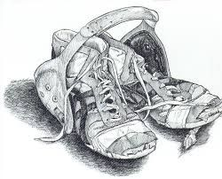

|  |  |  |
| --- | --- | --- |
| **INDIVIDUAL AREA CHAMPIONS (SINCE 1997…)** | | |
| **DUSTY BROWN** | **119** | **1997** |
| **CHRIS BUTLER** | **145** | **1997** |
| **BRANDON GORDON** | **285** | **1997** |
| **DUSTY BROWN** | **125** | **1998** |
| **CHRIS BUTLER** | **145** | **1998** |
| **KEVIN ESPY** | **152** | **1998** |
| **CHRIS BUTLER** | **152** | **1999** |
| **MICHAEL STALLINGS** | **171** | **1999** |
| **ANDY STIVERS** | **215** | **1999** |
| **BRANDON CARLTON** | **103** | **2002** |
| **ALAN HAWKINS** | **160** | **2002** |
| **BRANDON CARLTON** | **113** | **2003** |
| **JOSE MEDRANO** | **119** | **2003** |
| **BILLY HENDERSON** | **189** | **2003** |
| **RANDALL ABERNATHY** | **215** | **2003** |
| **JOSE MEDRANO** | **119** | **2004** |
| **BRANDON SIFFLES** | **119** | **2009** |
| **CODY SIFFLES** | **130** | **2009** |
| **JOHN REECE** | **140** | **2009** |
| **TYLER BURDICK** | **171** | **2009** |
| **J.J. BLANKENSHIP** | **103** | **2010** |
| **BRANDON SIFFLES** | **130** | **2010** |
| **CODY SIFFLES** | **135** | **2010** |
| **AUSTIN BURDICK** | **152** | **2010** |
| **J.J. BLANKENSHIP** | **112** | **2011** |
| **BRANDON SIFFLES** | **140** | **2011** |
| **BRANDON SIFFLES** | **152** | **2012** |
| **BRANDON BROWN** | **120** | **2013** |
| **J.J. BLANKENSHIP** | **126** | **2013** |
| **HAYDEN BURDICK** | **132** | **2013** |
| **GRIFFIN JARRETT** | **106** | **2017** |
| **AUSTIN JONES** | **195** | **2017** |
| **ALEX MEARS** | **220** | **2017** |
| **GRIFFIN JARRETT** | **106** | **2018** |
| **ALEX MEARS** | **195** | **2018** |
| **GRIFFIN JARRETT** | **106** | **2019** |
| **TY VEATCH** | **195** | **2019** |
| **ALEX MEARS** | **220** | **2019** |
| **LUIS MEDINA** | **285** | **2019** |
| **GRIFFIN JARRETT** | **113** | **2020** |
| **WES CONLEY** | **120** | **2020** |
| **MASON STERNER** | **145** | **2020** |
| **ROWAN BURDICK** | **152** | **2020** |
| **TY VEATCH** | **195** | **2020** |
| **ALEX MEARS** | **220** | **2020** |
| **LUIS MEDINA** | **285** | **2020** |
| **ROWAN BURDICK** | **160** | **2021** |
| **TY VEATCH** | **220** | **2021** |
| **LANDON CARLTON** | **106** | **2022** |
| **JOHNATHAN MEJIA** | **120** | **2022** |
| **GAVIN CARLTON** | **138** | **2022** |
| **DEVON HEROCH** | **220** | **2022** |